SHORT SKILLS PROGRAMME: MICT-TECHNICAL SUPPORT
49 CREDITS
SAQA UNIT STANDARD:14913
EXPLAIN THE PRINCIPLES OF COMPUTER NETWORKS
SUMMATIVE ASSESSMENT

Copyright:
All rights reserved. The copyright of this document, its previous editions and any annexures thereto, is protected and expressly reserved. No part of this document may be reproduced, stored in a retrievable system, or transmitted, in any form or by any means, electronic, mechanical, photocopying, recording or otherwise without the prior permission.

CANDIDATE DETAILS
LEARNER NAME(S):
LEARNER SURNAME:
ID NUMBER:
NAME OF ASSESSOR:
DATE OF ASSESSMENT:
VENUE:
 |  |  | ACHIEVED |  |  |  |  |  |  |  |  |  | NOT ACHIEVED
KNOWLEDGE:
SKILLS:
Signature of Learner: |  |  |  |  |  |  |  |  | Signature of Assessor:
ASSESSMENT PLAN
ASSESSMENT DETAILS:
DATE OF ASSESSMENT: |  |  |  |  |  | Option 1 |  |  |  |  |  | Option 2 |  |  |  |  | Option 3
TIME OF ASSESSMENT: |  |  |  |  |  | Start: |  |  |  |  |  |  |  |  |  | End:
Venue: |  |  |  |  |  |  |  | Contact Person:
LANGUAGE MEDIUM: |  |  | ENGLISH
METHOD OF ASSESSMENT
OBSERVATION |  |  |  | ORAL |  |  |  |  |  |  |  |  |  |  | WRITTEN
SIMULATION |  |  |  | KNOWLEDGE TEST |  |  |  |  |  |  |  |  |  |  | KNOWLEDGE TEST |  |  | X
PRODUCT |  |  |  | INTERVIEW
PRE-ASSESSMENT MEETING CHECKLIST

ACTION: |  |  |  |  |  |  | YES/NO: |  |  |  | COMMENTS:
Set learner at ease; be friendly, polite and professional.
Explain to the learner and agree on the following issues:
- The unit standard that will be assessed
- Date, time, venue and process to be followed during the assessment
- Summative assessment tools to be used for the assessment
- The assessment plan
- Purpose of assessment
Explain to the learner and agree on the role of all involved during the assessment process.
Identify possible barriers and or disabilities of the learner.
Explain the meaning and application of RPL.
Explain, discuss and provide one complete set of the Appeals process documentation.
Explain to the learner when final results will be available and how feedback will be provided.
Discuss previous assessment results, if applicable.
I, ______________________________________________________ (initials and surname of learner),
DECLARE THE FOLLOWING:
A copy of the module has been given to me prior to this meeting. I know I will be assessed against the criteria, which have been set to the applicable module. The criteria have been discussed with me, and the procedures and purpose of the assessment has been clearly explained to me.

I am well aware of the venue, date and time that I will be assessed. I consider the period of time given to me to prepare myself for the assessment to be fair.

I understand clearly that I have the right to appeal against any decision made by the assessor during the assessment of the evidence provided by me, and that I have free access to the appeals procedures attached to this assessment pack. I understand that I have the right to be accompanied by another person during all procedures.
Signature of Learner |  |  |  |  | Date

ASSESSMENT PACK
Please complete the following sections (A and B) before commencing with this assessment. The moderator of this assessment will complete section C.
Section A: LEARNER INFORMATION
Name:
Surname:
Contact Details:
Apprenticeship Agreement no:
Company:
Site: |  |  |  |  |  |  |  |  |  |  |  |  |  |  | Date:
ID
Section B: ASSESSOR INFORMATION
Name:
Surname:
Contact Details:
Assessor No:
Provider No:
Site: |  |  |  |  |  |  |  |  |  |  |  |  |  |  | Date:
ID
Section C: MODERATOR INFORMATION
Name:
Surname:
Contact Details:
Moderator No:
Provider No:
Site: |  |  |  |  |  |  |  |  |  |  |  |  |  |  | Date:
ID
RESULTS:

SESSION 1: EXPLAIN THE PRINCIPLES OF COMPUTER NETWORKS
Learning outcomes

Activity | Activity Description | Marks
1 | The diagram below shows the data communication system. Explain the role of each element shown on the diagram in data communication. | 8

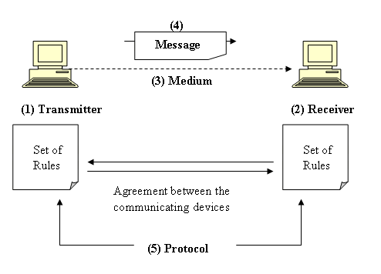
_____________________________________________________________________________________________________________________________________________________________________________________________________________________________________________________________________________________________________________________________________________________________________________________________________________________________________________________________________________________
__________________________________________________________________________________
Activity | Activity Description | Marks
2 | Identify the LAN media shown in the diagrams below; | 3
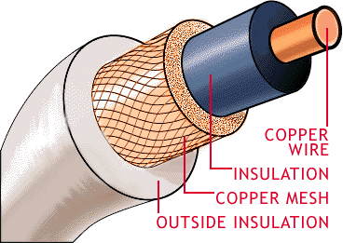 | Picture 1
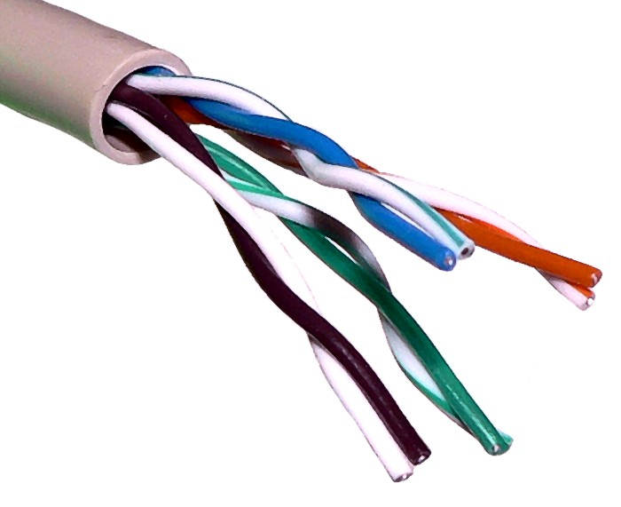 | Picture 2
 | Picture 3

Activity | Activity Description | Marks
3 | Draw the following LAN configurations;  - Star  - Bus  - Ring | 6

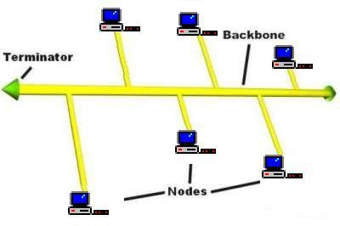
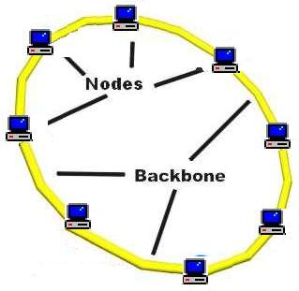
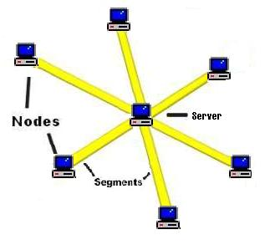

Activity | Activity Description | Marks
4 | List 4 examples of LAN protocols | 4
________________________________________________________________________________________________________________________________________________________________________________________________________________________________________________________________________________________________________________________________________
Activity | Activity Description | Marks
5 | Explain the role of WAN in remote sharing of data | 3
____________________________________________________________________________________________________________________________________________________________________________________________________________________________________________________________________________________________________________________________________________________________________________________________________________________________________________________________________________________________________________________________________________________________________________________________________________________________________________________________________________________________________________________________________________________________________________________________________________________________________________________
Activity | Activity Description | Marks
SECTION B
You are required to plan and conduct a 30 minutes presentation in the presence of your mentor or supervisor. The following must be covered;
- Uses of LAN in the organisation
- The main types of LAN media used by the organisation
- The LAN configurations available in the organisation
- Benefits of WAN to the organisation

NB
The mentor or supervisor must observe the presentation and complete the attached observation checklist.

PRESENTATION OBSERVATION CHECKLIST

LEARNER: _________________________________________________

DATE: _______________________ TOTAL SCORED: _______/80

Delivered his/her instructional presentation according to the following criteria:

Mark questions in the following manner:

ITEM | DESCRIPTION | MARKS
1 | PREPARATION
1.1 | Research and gathering of relevant information
 |  | /5
2. | INTRODUCTION
2.1 | Gains attention properly
2.2 | Gives brief overview and purpose of the presentation
 |  | /5
3. | PRESENTATION
3.1 | Gives clear explanation of;  - Uses of LAN in the organisation  - The main types of LAN media used by the organisation  - The LAN configurations available in the organisation  - Benefits of WAN to the organisation
 |  | /20
4. | TECHNIQUES
4.1 | Good flow and sequencing
4.2 | Proper questioning and feedback
4.3 | Appropriate integration of media and visuals
4.4 | Correct use of tone, volume, intonation and pitch | /5
5. | CONCLUSION
5.1 | Proper summary and consolidation
5.2 | Evaluates for outcomes
5.3 | Links with subsequent topic
 |  | /5
6 | GENERAL
6.1 | Proper time management
6.2 | Body language
6.3 | Relationship with learners
6.4 | General atmosphere
 |  | /5
 | TOTAL

Name of mentor | Signature & Date
Name of endorsing assessor | Signature & Date

ASSESSMENT FEEDBACK REPORT
FACILITATOR FEEDBACK & REMARKS:
ASSESSMENT JUDGEMENT |  |  |  | (Please Mark Relevant)
Learner’s Total Mark: |  |  |  | Requirements met: | YES / NO
Action/s required:

By when:
LEARNER FEEDBACK & COMMENTS
DECLARATION BY THE FACILITATOR
I, ___________________________________ hereby certify that I have examined the learner workbook and I am satisfied with the evidence provided by the learner.
DECLARATION BY LEARNER
I, ____________________________________ declare that I am satisfied that the feedback given to me by the Facilitator was relevant, sufficient and done in a constructive manner.
I accept the assessment judgment and have no further questions relating to this particular assessment event.
Learner Signature: | Date: |  | Facilitator Signature: |  | Date:
DECLARATION BY THE ASSESSOR
I, _____________________________________ hereby certify that I have examined the learner workbook and I am satisfied with the Facilitator Judgment of this assessment.
Assessor Signature: | Date: |  | Moderator Signature: |  | Date:

