LEARNERSHIP PROGRAMME: MICT-TECHNICAL SUPPORT 49 CREDITS
SAQA UNIT STANDARD:14952

DESCRIBE AND INSTALL A FACSIMILE MACHINE

FORMATIVE ASSESSMENT

Copyright:
All rights reserved. The copyright of this document, its previous editions and any annexures thereto, is protected and expressly reserved. No part of this document may be reproduced, stored in a retrievable system, or transmitted, in any form or by any means, electronic, mechanical, photocopying, recording or otherwise without the prior permission.

CANDIDATE DETAILS
LEARNER NAME(S):

LEARNER SURNAME:
ID NUMBER:
NAME OF ASSESSOR:
DATE OF ASSESSMENT:
VENUE:
 |  |  | ACHIEVED |  |  |  |  |  |  | NOT ACHIEVED
KNOWLEDGE:
SKILLS:
Signature of Learner: |  |  |  |  |  |  | Signature of Assessor:
ASSESSMENT PLAN
ASSESSMENT DETAILS:
DATE OF ASSESSMENT: |  |  |  |  | Option 1 |  |  |  | Option 2 |  |  |  |  | Option 3
TIME OF ASSESSMENT: |  |  |  |  | Start: |  |  |  |  |  |  |  | End:
Venue: |  |  |  |  |  | Contact Person:
LANGUAGE MEDIUM: |  |  | ENGLISH
METHOD OF ASSESSMENT
OBSERVATION |  |  |  | ORAL |  |  |  |  |  |  |  | WRITTEN
SIMULATION |  |  |  | KNOWLEDGE  TEST |  |  |  |  |  |  |  | KNOWLEDGE  TEST |  |  | X
PRODUCT |  |  |  | INTERVIEW
PRE-ASSESSMENT MEETING CHECKLIST
 | ACTION: |  |  |  | YES/NO: |  |  |  |  |  |  |  | COMMENTS:

Set learner at ease; be friendly, polite and professional.
Explain to the learner and agree on the following issues:
- The unit standard that will be assessed
- Date, time, venue and process to be followed during the assessment
- Summative assessment tools to be used for the assessment
- The assessment plan
- Purpose of assessment
Explain to the learner and agree on the role of all
involved during the assessment process.
Identify possible barriers and or disabilities of the learner.
Explain the meaning and application of RPL.
Explain, discuss and provide one complete set of the
Appeals process documentation.
Explain to the learner when final results will be
available and how feedback will be provided.
Discuss previous assessment results, if applicable.
I, (initials and surname of learner),
DECLARE THE FOLLOWING:
A copy of the module has been given to me prior to this meeting. I know I will be assessed against the criteria, which have been set to the applicable module. The criteria have been discussed with me, and the procedures and purpose of the assessment has been clearly explained to me.

I am well aware of the venue, date and time that I will be assessed. I consider the period of time given to me to prepare myself for the assessment to be fair.

I understand clearly that I have the right to appeal against any decision made by the assessor during the assessment of the evidence provided by me, and that I have free access to the appeals procedures attached to this assessment pack. I understand that I have the right to be accompanied by another person during all
procedures.
Signature of Learner | Date

ASSESSMENT PACK
Please complete the following sections (A and B) before commencing with this assessment. The moderator of this assessment will complete section C.

Section A: LEARNER INFORMATION
Name:
Surname:
Contact Details:
Apprenticeship Agreement no:
Company:
Site: |  |  |  |  |  |  |  |  |  |  |  |  |  | Date:
ID
Section B: ASSESSOR INFORMATION
Name:
Surname:
Contact Details:
Assessor No:
Provider No:
Site: |  |  |  |  |  |  |  |  |  |  |  |  |  | Date:
ID
Section C: MODERATOR INFORMATION
Name:
Surname:
Contact Details:
Moderator
No:
Provider No:
Site: |  |  |  |  |  |  |  |  |  |  |  |  |  | Date:
ID
RESULTS:

SESSION 1: Demonstrate an understanding of the use of preventive maintenances and procedures

Learning outcomes

Activity | Activity Description | Marks
1 | Question 1 (SO 1, AC 3)  Using the fax machine shown below identify the following components.  - Component 1:  - Component 2:  - Component 3:  - Component 4: (4)  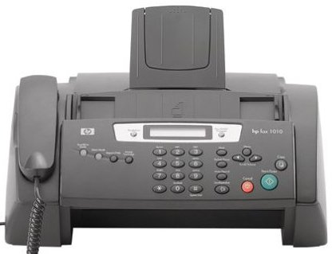  4  3  2 | 4
1

2

Activity | Activity Description | Marks
2 | Identify the component number 7; explain its usage and installation requirements.  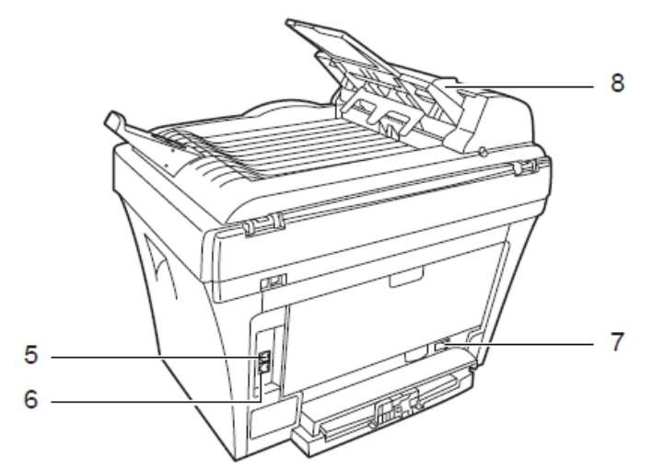 | 5

Activity | Activity Description | Marks
3 | Identity the key elements of a facsimile instillation plan. | 6

ASSESSMENT FEEDBACK REPORT
FACILITATOR FEEDBACK & REMARKS:
ASSESSMENT JUDGEMENT |  | (Please Mark Relevant)
Learner’s Total Mark: |  | Requirements  met: | YES / NO

Action/s required:

By when:
LEARNER FEEDBACK & COMMENTS
DECLARATION BY THE FACILITATOR
I, hereby certify that I have examined the learner workbook and I am satisfied with the evidence provided by the learner.
DECLARATION BY LEARNER
I, declare that I am satisfied that the feedback given to me by the Facilitator was relevant, sufficient and done in a constructive manner.
I accept the assessment judgment and have no further questions relating to this particular assessment
event.
Learner Signature: | Date: | Facilitator Signature: | Date:
DECLARATION BY THE ASSESSOR
I, hereby certify that I have examined the learner workbook and I am satisfied with the Facilitator Judgment of this assessment.
Assessor Signature: | Date: | Moderator Signature: | Date:

