LEARNERSHIP PROGRAMME: MICT-TECHNICAL SUPPORT 10 CREDITS
SAQA UNIT STANDARD: 119467

Use language and communication in occupational learning programmes
SUMMATIVE ASSESSMENT

Copyright:
All rights reserved. The copyright of this document, its previous editions and any annexures thereto, is protected and expressly reserved. No part of this document may be reproduced, stored in a retrievable system, or transmitted, in any form or by any means, electronic, mechanical, photocopying, recording or otherwise without the prior permission.

CANDIDATE DETAILS
LEARNER NAME(S):
LEARNER SURNAME:
ID NUMBER:
NAME OF ASSESSOR:
DATE OF ASSESSMENT:
VENUE:
 |  |  | ACHIEVED |  |  |  |  |  |  |  |  |  | NOT ACHIEVED
KNOWLEDGE:
SKILLS:
Signature of Learner: |  |  |  |  |  |  |  |  | Signature of Assessor:
ASSESSMENT PLAN
ASSESSMENT DETAILS:
DATE OF ASSESSMENT: |  |  |  |  |  | Option 1 |  |  |  |  |  | Option 2 |  |  |  |  | Option 3
TIME OF ASSESSMENT: |  |  |  |  |  | Start: |  |  |  |  |  |  |  |  |  | End:
Venue: |  |  |  |  |  |  |  | Contact Person:
LANGUAGE MEDIUM: |  |  | ENGLISH
METHOD OF ASSESSMENT
OBSERVATION |  |  |  | ORAL |  |  |  |  |  |  |  |  |  |  | WRITTEN
SIMULATION |  |  |  | KNOWLEDGE TEST |  |  |  |  |  |  |  |  |  |  | KNOWLEDGE TEST |  |  | X
PRODUCT |  |  |  | INTERVIEW
PRE-ASSESSMENT MEETING CHECKLIST

ACTION: |  |  |  |  |  |  | YES/NO: |  |  |  | COMMENTS:
Set learner at ease; be friendly, polite and professional.
Explain to the learner and agree on the following issues:
- The unit standard that will be assessed
- Date, time, venue and process to be followed during the assessment
- Summative assessment tools to be used for the assessment
- The assessment plan
- Purpose of assessment
Explain to the learner and agree on the role of all involved during the assessment process.
Identify possible barriers and or disabilities of the learner.
Explain the meaning and application of RPL.
Explain, discuss and provide one complete set of the Appeals process documentation.
Explain to the learner when final results will be available and how feedback will be provided.
Discuss previous assessment results, if applicable.
I, ______________________________________________________ (initials and surname of learner),
DECLARE THE FOLLOWING:
A copy of the module has been given to me prior to this meeting. I know I will be assessed against the criteria, which have been set to the applicable module. The criteria have been discussed with me, and the procedures and purpose of the assessment has been clearly explained to me.

I am well aware of the venue, date and time that I will be assessed. I consider the period of time given to me to prepare myself for the assessment to be fair.

I understand clearly that I have the right to appeal against any decision made by the assessor during the assessment of the evidence provided by me, and that I have free access to the appeals procedures attached to this assessment pack. I understand that I have the right to be accompanied by another person during all procedures.
Signature of Learner |  |  |  |  | Date

ASSESSMENT PACK
Please complete the following sections (A and B) before commencing with this assessment. The moderator of this assessment will complete section C.
Section A: LEARNER INFORMATION
Name:
Surname:
Contact Details:
Apprenticeship Agreement no:
Company:
Site: |  |  |  |  |  |  |  |  |  |  |  |  |  |  | Date:
ID
Section B: ASSESSOR INFORMATION
Name:
Surname:
Contact Details:
Assessor No:
Provider No:
Site: |  |  |  |  |  |  |  |  |  |  |  |  |  |  | Date:
ID
Section C: MODERATOR INFORMATION
Name:
Surname:
Contact Details:
Moderator No:
Provider No:
Site: |  |  |  |  |  |  |  |  |  |  |  |  |  |  | Date:
ID
RESULTS:


SESSION 1: Work on the following tasks, gathering evidence and attaching all documentation used. Be as practical as possible and use current and past projects to answer the questions asked.
Learning outcomes
You are required to comply with service levels as set out in a Contact Centre Operation. After the completion of the assessment process you will be able to:
- Demonstrate an understanding of company specific service levels.

- Meet and maintain service levels.

Note:
In order to achieve the objectives listed above,
  - Identify and select a company with in-bound and/or out-bound Contact Centres that are within a commercial or emergency context. You may use your workplace.

  - Compile a brief report providing details about the company

  - Complete the following tasks and attach all relevant evidence in your POE guide

Section A  1 | Identify the learning resources that a student studying towards a Certificate in Communication (NQF Level 4) might require. | 4

2 | Assume you were using the following textbook when writing an assignment on communication.  Show how you shall acknowledge the textbook under your reference section. (Using the Harvard referencing style) | 4
  Professional Communication-
  - ISBN9780702177927
  - Pages320
  - Authors English, J (Editor)
  Edition 3rd Edition
  - Published 2012
  - Publisher: Longman (UK)

3 | What are some of the factors that a group of students conducting a brainstorming session must consider to make it effective? | 8

4 | Identify the reasons why a learner must ask questions when reading a textbook chapter | 3

5 | List the key steps of conducting a research | 8

6 | Identify 4 factors in the workplace that affects occupational learning.

7 | What is your occupation and what occupational factors can affect you when learning on a part-time basis?  Explain how you can manage these factors. | 3

Section B  1 | Work on the following tasks, gathering evidence and attaching all documentation used. Be as practical as possible and use current and past projects to answer the questions asked Assume you are studying for a course in business communication. Below is an extract from one of the communication manuals. Use this extract to answer questions that follow  1.1 INTRODUCTION  Why is communication important to business? Couldn’t we just learn to punch numbers?  Good communication matters because business organisations are made up of people. As Robert Kent, former dean of Harvard Business School once said, “In business, communication is everything.”  Research spanning several decades has consistently ranked communication skills as crucial for managers. Typically, managers spend 75 to 80 percent of their time engaged in some form of communication. Communication is essence of management. The basic functions of management (Planning, Organising, Staffing, Directing and Controlling) cannot be performed well without effective communication.  From this definition we see that communication is a two-way process - it is not only giving information, opinions or ideas but also receiving such communication from others. There must be complete understanding by both parties involved in the communication process. Therefore, when we communicate, we must always make sure that our communication is suited to the person receiving it and that it can and will be understood by them.    In your own words, define communication using examples from your workplace.  1.2 PROCESS OF COMMUNICATION  Communication is a process of exchanging verbal and non verbal messages. It is a continuous process. Pre-requisite of communication is a message. This message must be conveyed through some medium to the recipient. It is essential that this message must be understood by the recipient in same terms as intended by the sender. The receiver must respond within a time frame. Thus, communication is a two way process and is incomplete without a feedback from the recipient to the sender on how well the message is understood by him. Figure 1 below shows the communication process,  FIGURE 1: COMMUNICATION PROCESS  The main components of communication process are as follows:  - Context - Communication is affected by the context in which it takes place. This context may be physical, social, chronological or cultural. Every communication proceeds with context. The sender chooses the message to communicate within a context.  - Sender / Encoder - Sender / Encoder is a person who sends the message. A sender makes use of symbols (words or graphic or visual aids) to convey the message and produce the required response. For instance - a training manager conducting training for new batch of employees. Sender may be an individual or a group or an organisation. The views, background, approach, skills, competencies, and knowledge of the sender have a great impact on the message. The verbal and non verbal symbols chosen are essential in ascertaining interpretation of the message by the recipient in the same terms as intended by the sender.  - Message - Once the sender has defined the information (the material from which the actual content of the communication will be constructed. Information can be factual or it could be a set of ideas / opinion - or a combination) that is to be transmitted, the sender must encode it. Once the information has been encoded, it is referred to as a message. Encoding means to put it into words (numbers or pictures, etc.). the message is the actual content of the communication - which is in fact a set of symbols conveying meaning  - Medium - Medium is a means used to exchange / transmit the message. The sender must choose an appropriate medium for transmitting the message otherwise the message might not be conveyed to the desired recipients. The choice of appropriate medium of communication is essential for making the message effective and correctly interpreted by the recipient. This choice of communication medium varies depending upon the features of communication. For instance - Written medium is chosen when a message has to be conveyed to a small group of people, while an oral medium is chosen when spontaneous feedback is required from the recipient as misunderstandings are cleared then and there.  - Receiver/Recipient / Decoder - Recipient / Decoder is a person for whom the message is intended / aimed / targeted. The degree to which the decoder understands the message is dependent upon various factors such as knowledge of recipient, their responsiveness to the message, and the reliance of encoder on decoder.  - Feedback - Feedback is the main component of communication process as it permits the sender to analyse the efficacy of the message. It helps the sender in confirming the correct interpretation of message by the decoder. Feedback may be verbal (through words) or non-verbal (in form of smiles, sighs, etc.). It may take written form also in form of memos, reports, etc.  The process of communication is best viewed as a succession of stages, namely:  1.3 PURPOSE OF COMMUNICATION  The purpose of communication can be defined as aiming at connecting in a sympathetic or meaningful way to exchange information, messages or ideas.  All people involved in the act of communication have an intention. The sender has the general intention of sending a message and the specific intention of conveying particular facts or requesting certain information. The receiver has the intention of both receiving the message and responding to the message.  Effective communication is not a one-way process. Communication is a matter of creating and building human relationships and not just about transmitting facts.  A person would communicate to achieve some of the following objectives as presented by Figure 2:  FIGURE 2: PURPOSE OF COMMUNICATION IN BUSINESS    Using your workplace explain the reasons why people communicate.  1.4 TYPES OF COMMUNICATION  Business communication is composed of three types;  - Written communication  - Oral communication  - Non-verbal communication  - Visual communication  1.4.1 WRITTEN COMMUNICATION  Written communication has great significance in today’s business world. It is an innovative activity of the mind. Effective written communication is essential for preparing worthy promotional materials for business development. Speech came before writing. But writing is more unique and formal than speech. Effective writing involves careful choice of words, their organisation in correct order in sentences formation as well as cohesive composition of sentences. Also, writing is more valid and reliable than speech. But while speech is spontaneous, writing causes delay and takes time as feedback is not immediate.  1.4.2 VERBAL/ORAL COMMUNICATION  Oral communication implies communication through mouth. It includes individuals conversing with each other, be it direct conversation or telephonic conversation. Speeches, presentations, discussions are all forms of oral communication. Oral communication is generally recommended when the communication matter is of temporary kind or where a direct interaction is required. Face to face communication (meetings, lectures, conferences, interviews, etc.) is significant so as to build a rapport and trust.  The following are the categories of verbal communication;  - Intra-personal communication is communication with one’s self. Talking to one’s self is an example of this.  - Extra-personal communication (as illustrated above) refers to communication to an inanimate object or non-human (plant or animal). For example, talking to a cat/dog or saying: “You naughty table!” after bumping your toe on it.  - Interpersonal communication refers to an ordinary conversation on a one-on-one basis, or a very small group. It may also refer to communication between groups of individuals (group discussions or informally in a crowd). For example, communication within and between departments in an organisation. (Face-to-Face)  - Telephonic communication refers to communicating verbally using an instrument such as the telephone. During this communication there is no visual feedback.  1.4.3 NON-VERBAL COMMUNICATION  Non-verbal communication involves physical ways of communication, like, tone of the voice, touch, smell and body motion. Creative and aesthetic non-verbal communication includes singing, music, dancing and sculpturing. Symbols and sign language are also included in non-verbal communication. Body language is a non-verbal way of communication. Body posture and physical contact convey a lot of information. Body posture matters a lot when you are communicating verbally to someone. Folded arms and crossed legs are some of the signals conveyed by a body posture. Physical contact, like, shaking hands, pushing, patting and touching expresses the feeling of intimacy. Facial expressions, gestures and eye contact are all different ways of communication.  1.4.4 VISUAL COMMUNICATION  The last type of communication out of the four types of communication is the visual communication. Visual communication is visual display of information, like, topography, photography, signs, symbols and designs. Television and video clips are the electronic form of visual communication.    Verbal, written, non-verbal and visual communication shall be covered in detail in later sessions.  Source: Business communication manual V1 (Striving Mind: Training Support)  Answer the following questions;  - Identify other relevant learning resources besides the manual that you might require for you to complete a course in communication.  - Read and summarise the above extract in less than 600 words  - Create a self assessment mind map for the above manual.  - Identify any 4 key questions that you might ask yourself inorder to check your understanding of the communication manual (extract).  - Explain the importance of communicating with other learners and facilitators during learning of this nature.  - Define the following terms used in the communication manual (extract);  - Body posture  - Message | 4  6  5  3  2  4
  Definition:  Communication | Communication is the giving, receiving or exchange of information, opinions or ideas by writing, speech or visual means so that the material communicated is completely understood. Sillars, 1994
  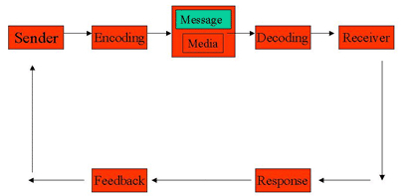
  Stage 1 | The sender decides what information is going to be transmitted.
  Stage 2 | The sender encodes this information. Puts the information into words (pictures or gestures)
  Stage 3 | The sender transmits the message to the receiver/s via a medium and a channel.
  Stage 4 | The receiver takes in the message, by reading, listening or watching.
  Stage 5 | The receiver decodes (interprets) the message.
  Stage 6 | The receiver expresses and initial reaction to the message (feedback)
  Stage 7 | The receiver makes a considered response to the message, e.g. asks a question or writes a letter of reply.  The stage starts the entire process again although it is considered part of the initial process, because it is a response. The roles of the receiver and sender interchange.
  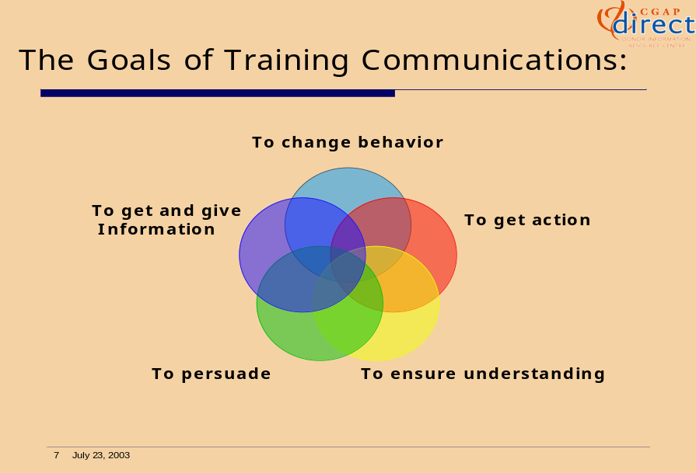

2 | You are required to plan, prepare and conduct a research on a topic of own interest. The results of the research must be presented in a research project which must be attached to the POE. Follow the guidelines that follow;  - Develop a research plan which outlines the following;  - Name of the research  - Scope of the research  - Target audience  - Research methodology to be used  - Research schedule  - Budget  - Conduct the research and present your results in a research report. The minimum requirements of the report are;  - Research background  - Data collection tools and techniques used  - Data processing  - Data analysis and presentation of results  - Recommendations and conclusions | 10  30

ASSESSMENT FEEDBACK REPORT
FACILITATOR FEEDBACK & REMARKS:
ASSESSMENT JUDGEMENT |  |  |  | (Please Mark Relevant)
Learner’s Total Mark: |  |  |  | Requirements met: | YES / NO
Action/s required:

By when:
LEARNER FEEDBACK & COMMENTS
DECLARATION BY THE FACILITATOR
I, ___________________________________ hereby certify that I have examined the learner workbook and I am satisfied with the evidence provided by the learner.
DECLARATION BY LEARNER
I, ____________________________________ declare that I am satisfied that the feedback given to me by the Facilitator was relevant, sufficient and done in a constructive manner.
I accept the assessment judgment and have no further questions relating to this particular assessment event.
Learner Signature: | Date: |  | Facilitator Signature: |  | Date:
DECLARATION BY THE ASSESSOR
I, _____________________________________ hereby certify that I have examined the learner workbook and I am satisfied with the Facilitator Judgment of this assessment.
Assessor Signature: | Date: |  | Moderator Signature: |  | Date:

