LEARNERSHIP PROGRAMME: MICT-TECHNICAL SUPPORT 10 CREDITS
SAQA UNIT STANDARD: 7468

USE MATHEMATICS TO INVESTIGATE AND MONITOR THE FINANCIAL ASPECTS OF PERSONAL, BUSINESS, NATIONAL AND INTERNATIONAL ISSUES
SUMMATIVE ASSESSMENT

Copyright:
All rights reserved. The copyright of this document, its previous editions and any annexures thereto, is protected and expressly reserved. No part of this document may be reproduced, stored in a retrievable system, or transmitted, in any form or by any means, electronic, mechanical, photocopying, recording or otherwise without the prior permission.

CANDIDATE DETAILS
LEARNER NAME(S):
LEARNER SURNAME:
ID NUMBER:
NAME OF ASSESSOR:
DATE OF ASSESSMENT:
VENUE:
 |  |  | ACHIEVED |  |  |  |  |  |  |  |  |  | NOT ACHIEVED
KNOWLEDGE:
SKILLS:
Signature of Learner: |  |  |  |  |  |  |  |  | Signature of Assessor:
ASSESSMENT PLAN
ASSESSMENT DETAILS:
DATE OF ASSESSMENT: |  |  |  |  |  | Option 1 |  |  |  |  |  | Option 2 |  |  |  |  | Option 3
TIME OF ASSESSMENT: |  |  |  |  |  | Start: |  |  |  |  |  |  |  |  |  | End:
Venue: |  |  |  |  |  |  |  | Contact Person:
LANGUAGE MEDIUM: |  |  | ENGLISH
METHOD OF ASSESSMENT
OBSERVATION |  |  |  | ORAL |  |  |  |  |  |  |  |  |  |  | WRITTEN
SIMULATION |  |  |  | KNOWLEDGE TEST |  |  |  |  |  |  |  |  |  |  | KNOWLEDGE TEST |  |  | X
PRODUCT |  |  |  | INTERVIEW
PRE-ASSESSMENT MEETING CHECKLIST

ACTION: |  |  |  |  |  |  | YES/NO: |  |  |  | COMMENTS:
Set learner at ease; be friendly, polite and professional.
Explain to the learner and agree on the following issues:
- The unit standard that will be assessed
- Date, time, venue and process to be followed during the assessment
- Summative assessment tools to be used for the assessment
- The assessment plan
- Purpose of assessment
Explain to the learner and agree on the role of all involved during the assessment process.
Identify possible barriers and or disabilities of the learner.
Explain the meaning and application of RPL.
Explain, discuss and provide one complete set of the Appeals process documentation.
Explain to the learner when final results will be available and how feedback will be provided.
Discuss previous assessment results, if applicable.
I, ______________________________________________________ (initials and surname of learner),
DECLARE THE FOLLOWING:
A copy of the module has been given to me prior to this meeting. I know I will be assessed against the criteria, which have been set to the applicable module. The criteria have been discussed with me, and the procedures and purpose of the assessment has been clearly explained to me.

I am well aware of the venue, date and time that I will be assessed. I consider the period of time given to me to prepare myself for the assessment to be fair.

I understand clearly that I have the right to appeal against any decision made by the assessor during the assessment of the evidence provided by me, and that I have free access to the appeals procedures attached to this assessment pack. I understand that I have the right to be accompanied by another person during all procedures.
Signature of Learner |  |  |  |  | Date

ASSESSMENT PACK
Please complete the following sections (A and B) before commencing with this assessment. The moderator of this assessment will complete section C.
Section A: LEARNER INFORMATION
Name:
Surname:
Contact Details:
Apprenticeship Agreement no:
Company:
Site: |  |  |  |  |  |  |  |  |  |  |  |  |  |  | Date:
ID
Section B: ASSESSOR INFORMATION
Name:
Surname:
Contact Details:
Assessor No:
Provider No:
Site: |  |  |  |  |  |  |  |  |  |  |  |  |  |  | Date:
ID
Section C: MODERATOR INFORMATION
Name:
Surname:
Contact Details:
Moderator No:
Provider No:
Site: |  |  |  |  |  |  |  |  |  |  |  |  |  |  | Date:
ID
RESULTS:

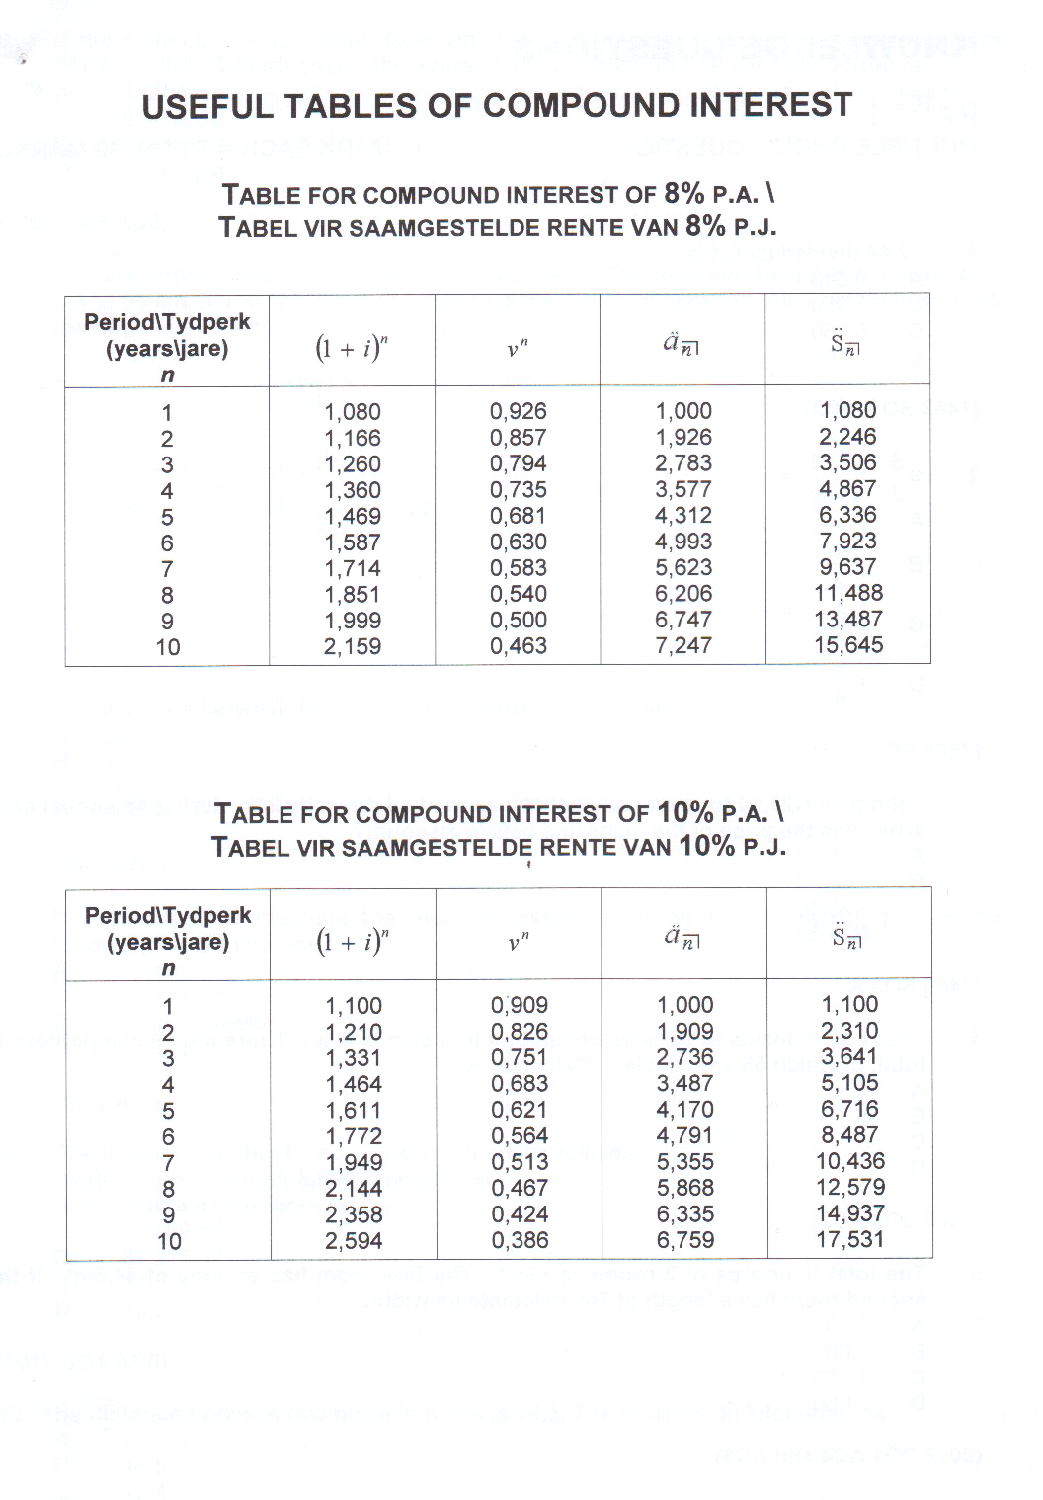

1 | Identify and describe the elements that must be taken into consideration when planning for the effective management of financial instruments. (8)  - Identify and explain ways that an investor can be used to control the following financial instruments in order to maximise profits and minimise losses.  Stock (3)  Bond (3)  Unit trusts (3) | 17

2 | Palesa took out an insurance policy for her new Mercedes benz c200k. The retail value for the car is R200 000. The excess on the policy is R4500. Unfortunately Palesa was involved in an accident and the cost of the accident was R4000. How much can she recover from insurance? | 3

3 | R620 800 is invested for 4 years at 8% p.a. compound interest. What will be the total of INTEREST be at the end of the 4 years? (NB Use the compound interest tables provided or work to three decimal places only.) (3)  Using a worked example explain the difference between simple and compound interest.  (8) | 11

4 | An investor places a sum of R100 000 in a US dollar denominated overseas fixed interest investment earning 6% p.a. compound for a one-year, and “repatriates” the investment with the interest at the end of the year. During the year period, the value of the Rand depreciates from R7,01 per Dollar to R7,29 per Dollar. Indicate whether this investment proves to be a better one than leaving the R100 000 in a local savings account earning 3% per annum, drawing on relevant calculations to support your argument. (Ignore any tax and charges for the purposes of this exercise.) | 8

5 | - Define the following terms;  - Marginal cost. (3)  - Marginal revenue. (3)  - Given the data they have provided you with (see table), compute the following:  - Total Revenue (TR) at each Quantity (Q) level (7)  - Marginal Revenue (MR) (7)  - Marginal Cost (MC) (7)  - Profit at every quantity level (7)  - Fixed Costs (1) | 38

Q | P | TC | TR | MR | MC | PROF
0 | 5 | 9
1 | 5 | 10
2 | 5 | 12
3 | 5 | 15
4 | 5 | 19
5 | 5 | 24
6 | 5 | 30
7 | 5 | 45

6 | Research and compare the economies of South Africa and Zimbabwe in terms of;  - Exchange rates  - Repo rates  - Inflation  - Balance of payments (imports and exports)  - Unemployment  Present your answers in a report format and use mathematical tools and systems to support your answers. | 15

7 | Debra works as a Community Health Worker in Lobatse Botswana. She works for the department of Health and is one of the delegates invited to the annual community health workers forum. The forum is being held in South Africa. Lobatse was given a travelling allowance of 5000 pula to use during her stay in South Africa. How much does Debra have in Rands? Assume the exchange rate is as follows R1 = 0.86 pula. Show all workings. | 2

ASSESSMENT FEEDBACK REPORT
FACILITATOR FEEDBACK & REMARKS:
ASSESSMENT JUDGEMENT |  |  |  | (Please Mark Relevant)
Learner’s Total Mark: |  |  |  | Requirements met: | YES / NO
Action/s required:

By when:
LEARNER FEEDBACK & COMMENTS
DECLARATION BY THE FACILITATOR
I, ___________________________________ hereby certify that I have examined the learner workbook and I am satisfied with the evidence provided by the learner.
DECLARATION BY LEARNER
I, ____________________________________ declare that I am satisfied that the feedback given to me by the Facilitator was relevant, sufficient and done in a constructive manner.
I accept the assessment judgment and have no further questions relating to this particular assessment event.
Learner Signature: | Date: |  | Facilitator Signature: |  | Date:
DECLARATION BY THE ASSESSOR
I, _____________________________________ hereby certify that I have examined the learner workbook and I am satisfied with the Facilitator Judgment of this assessment.
Assessor Signature: | Date: |  | Moderator Signature: |  | Date:

