LEARNERSHIP PROGRAMME: MICT-TECHNICAL SUPPORT 10 CREDITS
SAQA UNIT STANDARD: 9016
REPRESENT ANALYSE AND CALCULATE SHAPE AND MOTION IN 2 AND 3 DIMENSIONAL SPACE IN DIFFERENT CONTEXTS

FORMATIVE ASSESSMENT

Copyright:
All rights reserved. The copyright of this document, its previous editions and any annexures thereto, is protected and expressly reserved. No part of this document may be reproduced, stored in a retrievable system, or transmitted, in any form or by any means, electronic, mechanical, photocopying, recording or otherwise without the prior permission.

CANDIDATE DETAILS
LEARNER NAME(S):
LEARNER SURNAME:
ID NUMBER:
NAME OF ASSESSOR:
DATE OF ASSESSMENT:
VENUE:
 |  |  | ACHIEVED |  |  |  |  |  |  |  |  |  | NOT ACHIEVED
KNOWLEDGE:
SKILLS:
Signature of Learner: |  |  |  |  |  |  |  |  | Signature of Assessor:
ASSESSMENT PLAN
ASSESSMENT DETAILS:
DATE OF ASSESSMENT: |  |  |  |  |  | Option 1 |  |  |  |  |  | Option 2 |  |  |  |  | Option 3
TIME OF ASSESSMENT: |  |  |  |  |  | Start: |  |  |  |  |  |  |  |  |  | End:
Venue: |  |  |  |  |  |  |  | Contact Person:
LANGUAGE MEDIUM: |  |  | ENGLISH
METHOD OF ASSESSMENT
OBSERVATION |  |  |  | ORAL |  |  |  |  |  |  |  |  |  |  | WRITTEN
SIMULATION |  |  |  | KNOWLEDGE TEST |  |  |  |  |  |  |  |  |  |  | KNOWLEDGE TEST |  |  | X
PRODUCT |  |  |  | INTERVIEW
PRE-ASSESSMENT MEETING CHECKLIST

ACTION: |  |  |  |  |  |  | YES/NO: |  |  |  | COMMENTS:
Set learner at ease; be friendly, polite and professional.
Explain to the learner and agree on the following issues:
- The unit standard that will be assessed
- Date, time, venue and process to be followed during the assessment
- Summative assessment tools to be used for the assessment
- The assessment plan
- Purpose of assessment
Explain to the learner and agree on the role of all involved during the assessment process.
Identify possible barriers and or disabilities of the learner.
Explain the meaning and application of RPL.
Explain, discuss and provide one complete set of the Appeals process documentation.
Explain to the learner when final results will be available and how feedback will be provided.
Discuss previous assessment results, if applicable.
I, ______________________________________________________ (initials and surname of learner),
DECLARE THE FOLLOWING:
A copy of the module has been given to me prior to this meeting. I know I will be assessed against the criteria, which have been set to the applicable module. The criteria have been discussed with me, and the procedures and purpose of the assessment has been clearly explained to me.

I am well aware of the venue, date and time that I will be assessed. I consider the period of time given to me to prepare myself for the assessment to be fair.

I understand clearly that I have the right to appeal against any decision made by the assessor during the assessment of the evidence provided by me, and that I have free access to the appeals procedures attached to this assessment pack. I understand that I have the right to be accompanied by another person during all procedures.
Signature of Learner |  |  |  |  | Date

ASSESSMENT PACK
Please complete the following sections (A and B) before commencing with this assessment. The moderator of this assessment will complete section C.
Section A: LEARNER INFORMATION
Name:
Surname:
Contact Details:
Apprenticeship Agreement no:
Company:
Site: |  |  |  |  |  |  |  |  |  |  |  |  |  |  | Date:
ID
Section B: ASSESSOR INFORMATION
Name:
Surname:
Contact Details:
Assessor No:
Provider No:
Site: |  |  |  |  |  |  |  |  |  |  |  |  |  |  | Date:
ID
Section C: MODERATOR INFORMATION
Name:
Surname:
Contact Details:
Moderator No:
Provider No:
Site: |  |  |  |  |  |  |  |  |  |  |  |  |  |  | Date:
ID
RESULTS:

Question 1 (SO1, AC3)
- What is the instrument used to measure the following: [5]
- Small-hole gauge
- Electrical Values
- Chemical Analysis
- Short Distances in Meters
- Amount of milk in a container.

________________________________________________________________________________________________________________________________________________________________________________________________________________________________________________________________________________________________________________________________________________________________________________________________________________________________________________________________________________________________________________________________________________________________________________________________________________________________________________________________________________________________________________________________________________________________________________________________________________________________________________________________________________________________________________________________________________________________________________________________________________________________________________________________________________________________________________________________________________

Question 2 (SO1 AC3, AC4, AC6, AC7 ; SO 2 AC5)
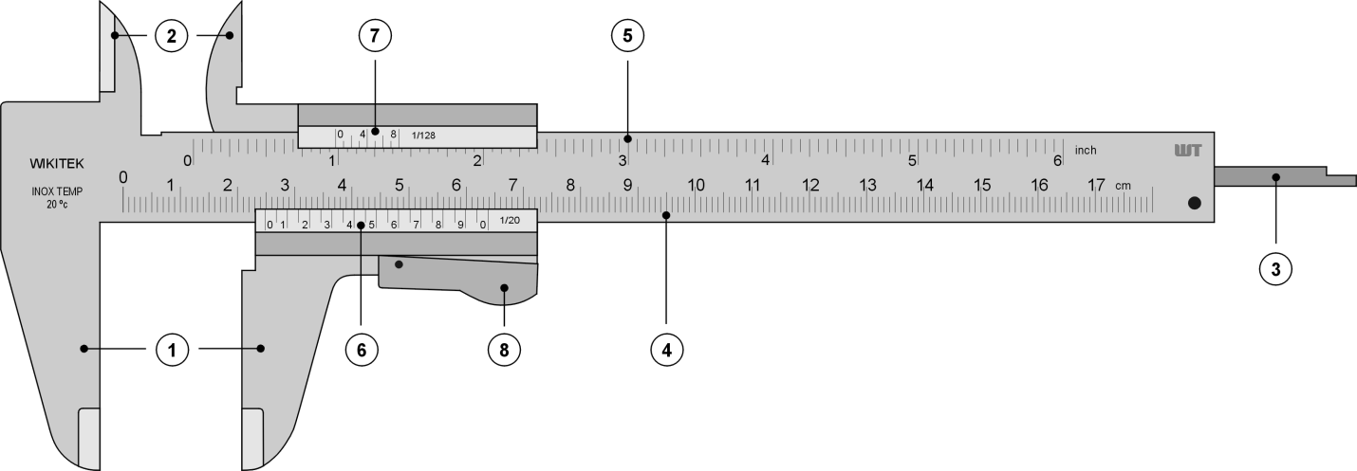

- What is the name of the above instrument? [1]
- Clearly label parts of the instrument [4]
- What is the SI unit for the measurement? [1]
- Briefly describe how the instrument function [3]

____________________________________________________________________________________________________________________________________________________________________________________________________________________________________________________________________________________________________________________________________________________________________________________________________________________________________________________________________________________________________________________________________________________________________________________________________________________________________________________________________________________________________________________________________________________________________________________________________________________________________________________________________________________________________________________________________________________________________________________________________________________________________________________________________________________________________________________________________________________________________________________________________________________________________________________________________________________________________________________________________________________________________________________________________________________________________________________________________________________________________________________________________________________________________________________________________________________________________________________________________________________________________________________________________________________________________________________________________________________________________________________________________________________________________________________________________________________________________________________________________________

Question 3 (SO 2, AC1, AC2, AC3, AC4)
- Below are names of the 4-sided 2-D shapes listed below:
- Square
- Rectangle
- Rhombus
- Trapezium
- Parallelogram
- Kite
Identify the shapes in the list which always have all angles with the same size. [2]
- You are given a 3-D shape that has four triangular faces and one square face. What is the name of the 3-D shape? [1]
- Below are a list of the 4-sided 2-D shapes listed below:
- Square
- Rectangle
- Rhombus
- Trapezium
- Parallelogram
- Kite
Identify the shapes in the list which always have diagonals which cross at right- angles. [3]

____________________________________________________________________________________________________________________________________________________________________________________________________________________________________________________________________________________________________________________________________________________________________________________________________________________________________________________________________________________________________________________________________________________________________________________________________________________________________________________________________________________________________________________________________________________________________________________________________________________________________________________________________________________________________________________________________________________________________________________________________________________________________________________________________________________________________________________________________________________________________________________________________________________________________________________________________________________________________________________________________________________________________________________________________________________________________

Question 4 (SO1 AC2, AC5, AC6, AC7 and SO2, AC3, AC4)
- A cube has all sides of length 2cm. What is the surface area and volume of the cuboid? [2]
- The same cube is enlarged with scale factor 5. What is the new surface area and volume? [3]

____________________________________________________________________________________________________________________________________________________________________________________________________________________________________________________________________________________________________________________________________________________________________________________________________________________________________________________________________________________________________________________________________________________________________________________________________________________________________________________________________________________________________________________________________________________________________________________________________________________________________________________________________________________________________________________________________________________________________________________________________________________________________________________________________________________________________________________________________________________________________________________________________________________________________________________________________________________________________________________________________________________________________________________________________________________________________

Question 5 (SO2, AC5, AC6, AC7,AC8,AC10)
Two similar rectangles are shown below
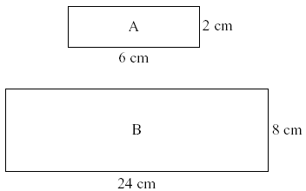
- Calculate the area of rectangle A [1]
- Calculate the area of rectangle B. [1]
- What scale factor produces the enlargement from A to B? [2]
- How many times bigger is the surface area of shape B to that of A? [2]

________________________________________________________________________________________________________________________________________________________________________________________________________________________________________________________________________________________________________________________________________________________________________________________________________________________________________________________________________________________________________________________________________________________________________________________________________________________________________________________________________________________________________________________________________________________________________________________________________________________________________________________________________________________________________________________________________________________________________________________________________________________________________________________________________________________________________________________________________________________________________________________________________________________________________________________________________________________________________________________________________________________________________________________________________________________________________________________________________________________________________________________________________________________________________________________________________________________________________________________________________________________________________________________
Question 7 (SO2, AC6, AC9, AC10)
A ladder rests against a wall 24m high. The foot of the ladder is 7m from the foot of the wall. Calculate the length of the ladder. [3]
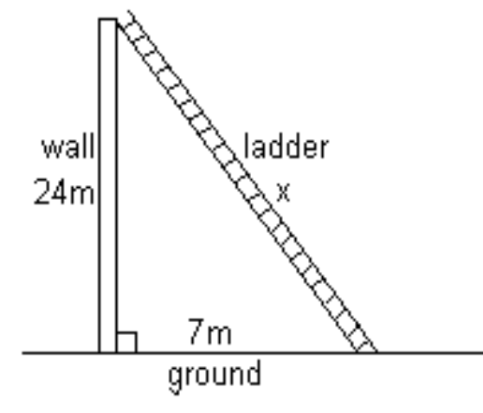

____________________________________________________________________________________________________________________________________________________________________________________________________________________________________________________________________________________________________________________________________________________________________________________________________________________________________________________________________________________________________________________________________________________________________________________________________________________________________________________________________________________________________________________________________________________________________________________________________________________________________________________________
Question 8 (SO2, AC9, AC10)
The flow chart below is used to identify quadrilaterals. Pick the correct quadrilateral for each output.

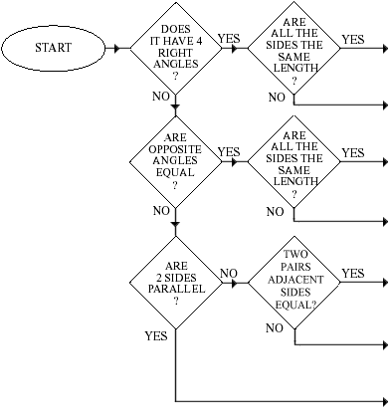



ASSESSMENT FEEDBACK REPORT
FACILITATOR FEEDBACK & REMARKS:
ASSESSMENT JUDGEMENT |  |  |  | (Please Mark Relevant)
Learner’s Total Mark: |  |  |  | Requirements met: | YES / NO
Action/s required:

By when:
LEARNER FEEDBACK & COMMENTS
DECLARATION BY THE FACILITATOR
I, ___________________________________ hereby certify that I have examined the learner workbook and I am satisfied with the evidence provided by the learner.
DECLARATION BY LEARNER
I, ____________________________________ declare that I am satisfied that the feedback given to me by the Facilitator was relevant, sufficient and done in a constructive manner.
I accept the assessment judgment and have no further questions relating to this particular assessment event.
Learner Signature: | Date: |  | Facilitator Signature: |  | Date:
DECLARATION BY THE ASSESSOR
I, _____________________________________ hereby certify that I have examined the learner workbook and I am satisfied with the Facilitator Judgment of this assessment.
Assessor Signature: | Date: |  | Moderator Signature: |  | Date:

