LEARNERSHIP PROGRAMME: MICT-TECHNICAL SUPPORT 10 CREDITS
SAQA UNIT STANDARD: 9016
REPRESENT ANALYSE AND CALCULATE SHAPE AND MOTION IN 2 AND 3 DIMENSIONAL SPACE IN DIFFERENT CONTEXTS

SUMMATIVE ASSESSMENT

Copyright:
All rights reserved. The copyright of this document, its previous editions and any annexures thereto, is protected and expressly reserved. No part of this document may be reproduced, stored in a retrievable system, or transmitted, in any form or by any means, electronic, mechanical, photocopying, recording or otherwise without the prior permission.

CANDIDATE DETAILS
LEARNER NAME(S):
LEARNER SURNAME:
ID NUMBER:
NAME OF ASSESSOR:
DATE OF ASSESSMENT:
VENUE:
 |  |  | ACHIEVED |  |  |  |  |  |  |  |  |  | NOT ACHIEVED
KNOWLEDGE:
SKILLS:
Signature of Learner: |  |  |  |  |  |  |  |  | Signature of Assessor:
ASSESSMENT PLAN
ASSESSMENT DETAILS:
DATE OF ASSESSMENT: |  |  |  |  |  | Option 1 |  |  |  |  |  | Option 2 |  |  |  |  | Option 3
TIME OF ASSESSMENT: |  |  |  |  |  | Start: |  |  |  |  |  |  |  |  |  | End:
Venue: |  |  |  |  |  |  |  | Contact Person:
LANGUAGE MEDIUM: |  |  | ENGLISH
METHOD OF ASSESSMENT
OBSERVATION |  |  |  | ORAL |  |  |  |  |  |  |  |  |  |  | WRITTEN
SIMULATION |  |  |  | KNOWLEDGE TEST |  |  |  |  |  |  |  |  |  |  | KNOWLEDGE TEST |  |  | X
PRODUCT |  |  |  | INTERVIEW
PRE-ASSESSMENT MEETING CHECKLIST

ACTION: |  |  |  |  |  |  | YES/NO: |  |  |  | COMMENTS:
Set learner at ease; be friendly, polite and professional.
Explain to the learner and agree on the following issues:
- The unit standard that will be assessed
- Date, time, venue and process to be followed during the assessment
- Summative assessment tools to be used for the assessment
- The assessment plan
- Purpose of assessment
Explain to the learner and agree on the role of all involved during the assessment process.
Identify possible barriers and or disabilities of the learner.
Explain the meaning and application of RPL.
Explain, discuss and provide one complete set of the Appeals process documentation.
Explain to the learner when final results will be available and how feedback will be provided.
Discuss previous assessment results, if applicable.
I, ______________________________________________________ (initials and surname of learner),
DECLARE THE FOLLOWING:
A copy of the module has been given to me prior to this meeting. I know I will be assessed against the criteria, which have been set to the applicable module. The criteria have been discussed with me, and the procedures and purpose of the assessment has been clearly explained to me.

I am well aware of the venue, date and time that I will be assessed. I consider the period of time given to me to prepare myself for the assessment to be fair.

I understand clearly that I have the right to appeal against any decision made by the assessor during the assessment of the evidence provided by me, and that I have free access to the appeals procedures attached to this assessment pack. I understand that I have the right to be accompanied by another person during all procedures.
Signature of Learner |  |  |  |  | Date
ASSESSMENT PACK
Please complete the following sections (A and B) before commencing with this assessment. The moderator of this assessment will complete section C.
Section A: LEARNER INFORMATION
Name:
Surname:
Contact Details:
Apprenticeship Agreement no:
Company:
Site: |  |  |  |  |  |  |  |  |  |  |  |  |  |  | Date:
ID
Section B: ASSESSOR INFORMATION
Name:
Surname:
Contact Details:
Assessor No:
Provider No:
Site: |  |  |  |  |  |  |  |  |  |  |  |  |  |  | Date:
ID
Section C: MODERATOR INFORMATION
Name:
Surname:
Contact Details:
Moderator No:
Provider No:
Site: |  |  |  |  |  |  |  |  |  |  |  |  |  |  | Date:
ID
RESULTS:

ASSESSMENT PACK
Please complete the following sections (A and B) before commencing with this assessment. The moderator of this assessment will complete section C.
Section A: LEARNER INFORMATION
Name:
Surname:
Contact Details:
Apprenticeship Agreement no:
Company:
Site: |  |  |  |  |  |  |  |  |  |  |  |  |  |  | Date:
ID
Section B: ASSESSOR INFORMATION
Name:
Surname:
Contact Details:
Assessor No:
Provider No:
Site: |  |  |  |  |  |  |  |  |  |  |  |  |  |  | Date:
ID
Section C: MODERATOR INFORMATION
Name:
Surname:
Contact Details:
Moderator No:
Provider No:
Site: |  |  |  |  |  |  |  |  |  |  |  |  |  |  | Date:
ID
RESULTS:



Activity | Activity Description | Marks
1 | - Name the instruments below.  - Read the measurement correctly  - What the SI unit for each measurement.  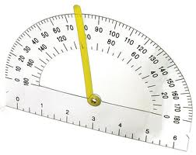  A  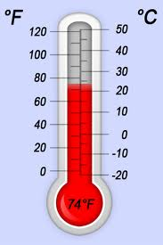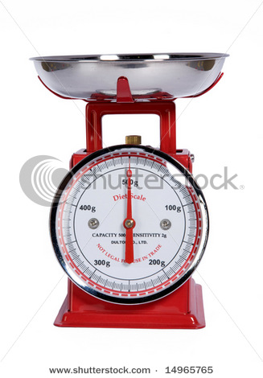  C  B  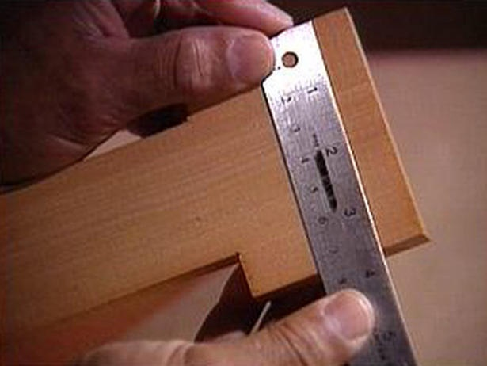  D  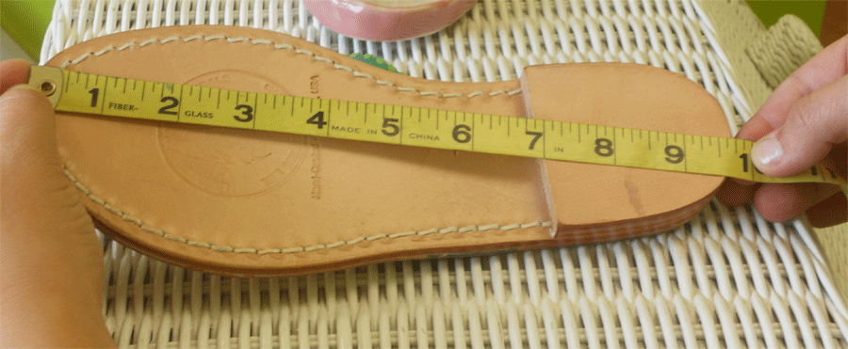  E | 5  5  5

Activity | Activity Description | Marks
2 | - You want to measure the volume of a vase which has an unusual shape in that it was crafted uniquely by a master glass bower. Thus no mathematical formula that you can use to do the calculation. Explain how you would go about this.  - Which of the following two containers would carry more water?  - A square box with sides of 200mm each.  - A rectangular box with sides of 80mm each and a length of 800mm | 2  3

Activity | Activity Description | Marks
3 | Janet and Bill leave their home at the same time. Janet has 60 miles to travel and drives at 40 m/h. Bill has 80 miles to travel and also drives at 40 m/h  - How long does Janet's journey take?  - How much longer does Bill spend driving than Janet? | 2  2

4 | A ship sails 300 km due west and then 100 km due south. At the end of this journey, how far is the ship from its starting position? | 5

5 | Ron's dad warned Ron his son not to walk on the lawn when going to the gate. The lawn is a rectangle with sides of lengths 10 m and 16 m. When his dad is around, Ron obeys and walks around the edges of the lawn until he gets to the gate (path A) . When his dad is not around, Ron walks diagonally across the lawn (path B). How much further does Ron have to walk to get to the gate from the house when his dad is around? Give your answer correct to 2 decimal places.  Gate  Path A  Path B  Door of the house | 5

6 | Your city council has decided to build a cone shaped reservoir. The plan that was given to the building contractor and it indicated that the top diameter of the reservoir must be 50m. The depth of the reservoir is indicated at 30m.  - What volume of water can be stored in the reservoir?  - What is the surface area of the wall of the cone? | 3  3

ASSESSMENT FEEDBACK REPORT
FACILITATOR FEEDBACK & REMARKS:
ASSESSMENT JUDGEMENT |  |  |  | (Please Mark Relevant)
Learner’s Total Mark: |  |  |  | Requirements met: | YES / NO
Action/s required:

By when:
LEARNER FEEDBACK & COMMENTS
DECLARATION BY THE FACILITATOR
I, ___________________________________ hereby certify that I have examined the learner workbook and I am satisfied with the evidence provided by the learner.
DECLARATION BY LEARNER
I, ____________________________________ declare that I am satisfied that the feedback given to me by the Facilitator was relevant, sufficient and done in a constructive manner.
I accept the assessment judgment and have no further questions relating to this particular assessment event.
Learner Signature: | Date: |  | Facilitator Signature: |  | Date:
DECLARATION BY THE ASSESSOR
I, _____________________________________ hereby certify that I have examined the learner workbook and I am satisfied with the Facilitator Judgment of this assessment.
Assessor Signature: | Date: |  | Moderator Signature: |  | Date:

